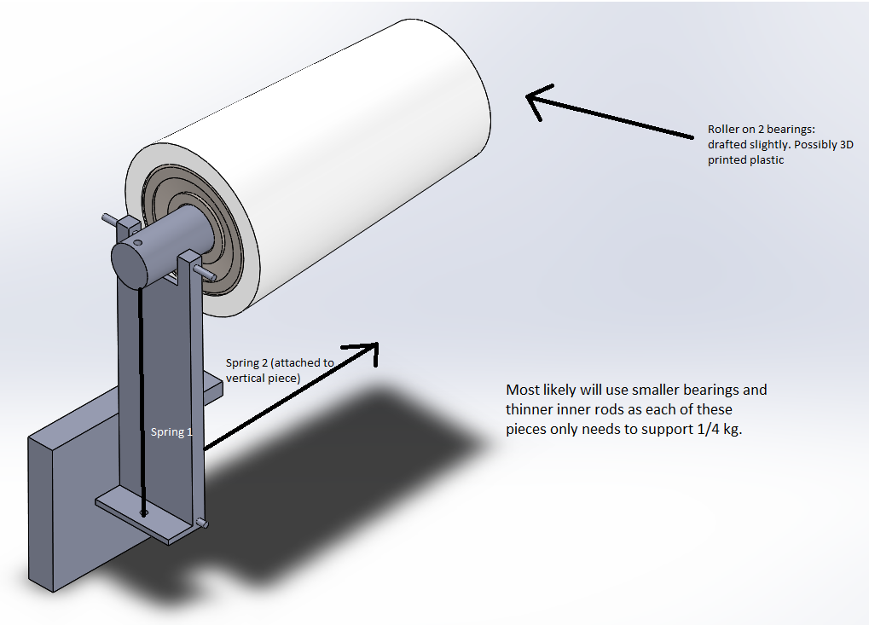The basket will separate from the main body of the robot and go down the zipline individually. In order to do this, the basket will be raised until the clip-on supports are pushed against the zipline. (These supports will cover about 8 inches horizontally, which is more than enough to deal with the 5 inches the zipline will move sideways in the 6 inches of length of our basket: the tendency for the zipline to move toward the center creates room for geometric error.) As the zipline is pressed against the supports, they will bend backwards until the zipline moves between them, and then spring back into place. (The supports will have a default position determined by the actual shape of the The springs will hold the supports so that when the basket raising mechanism is lowered, the zipline cannot fall through the supports. Finally, since the supports are mounted on bearings (low friction), the downward slope of the zipline (as well as the comparatively light weight of the basket, which stops the zipline from bending significantly) will cause the basket to be carried into the safe zone by gravity.